**BUILDING FACE DETECTION AWS APP**

**DASHBOARDS SCREENSHOTS:**

1.AWS LOGIN SCREEN WITH USER NAME:

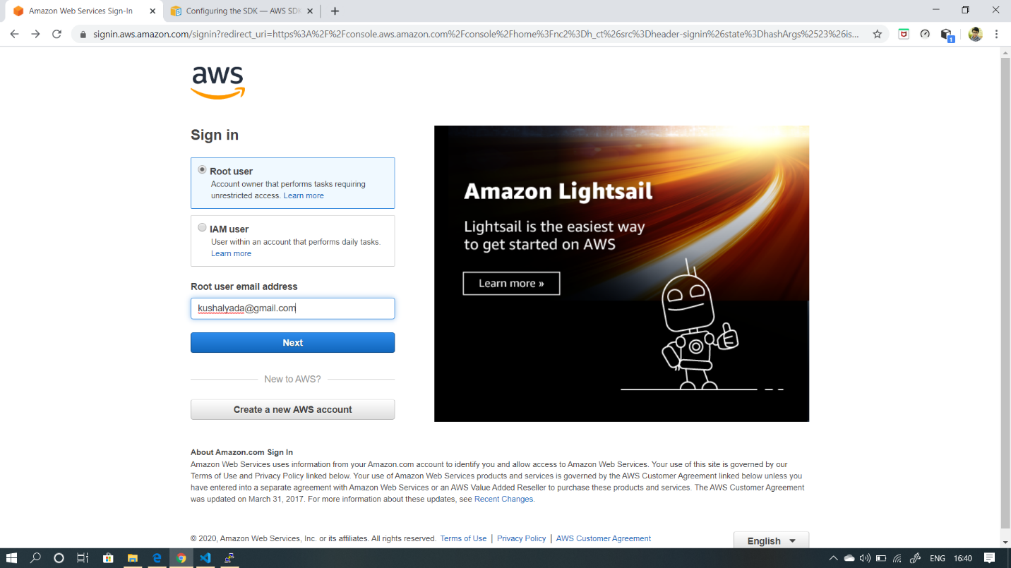

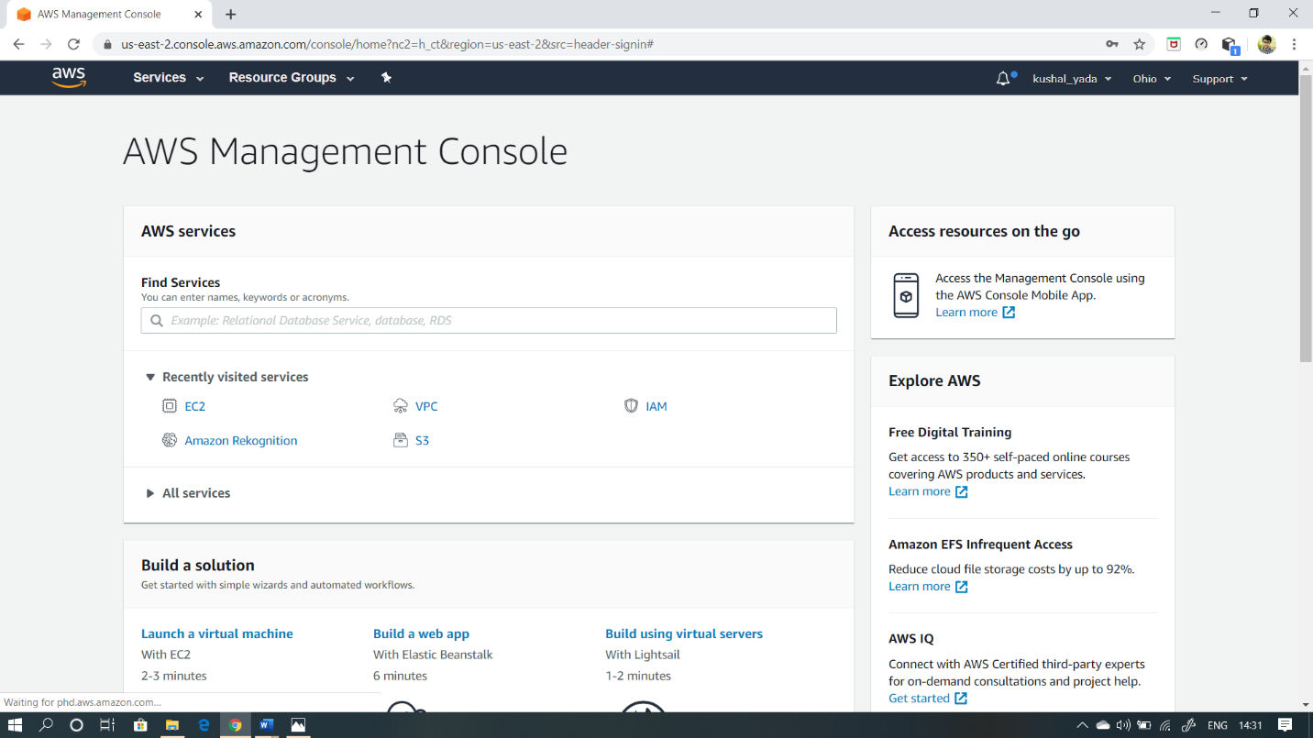

2.EC2 DASHBOARD:

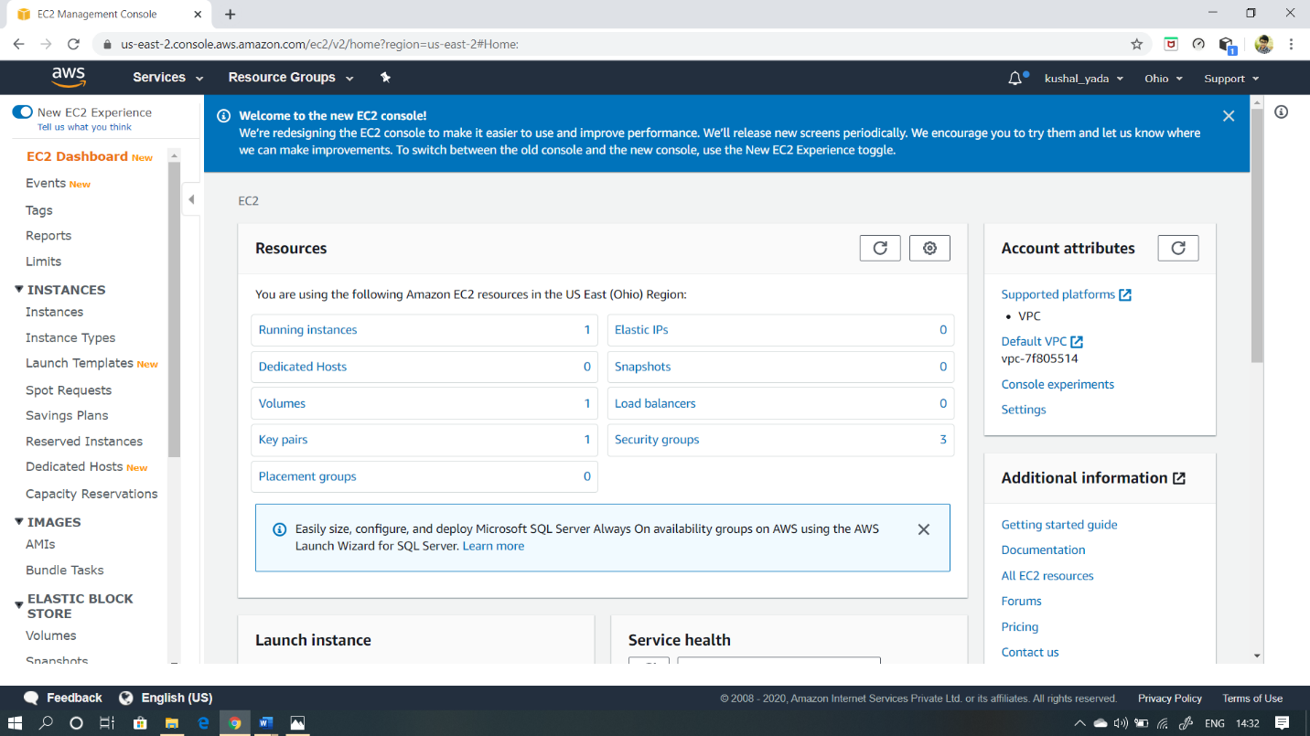

3.S3 DASHBOARD:

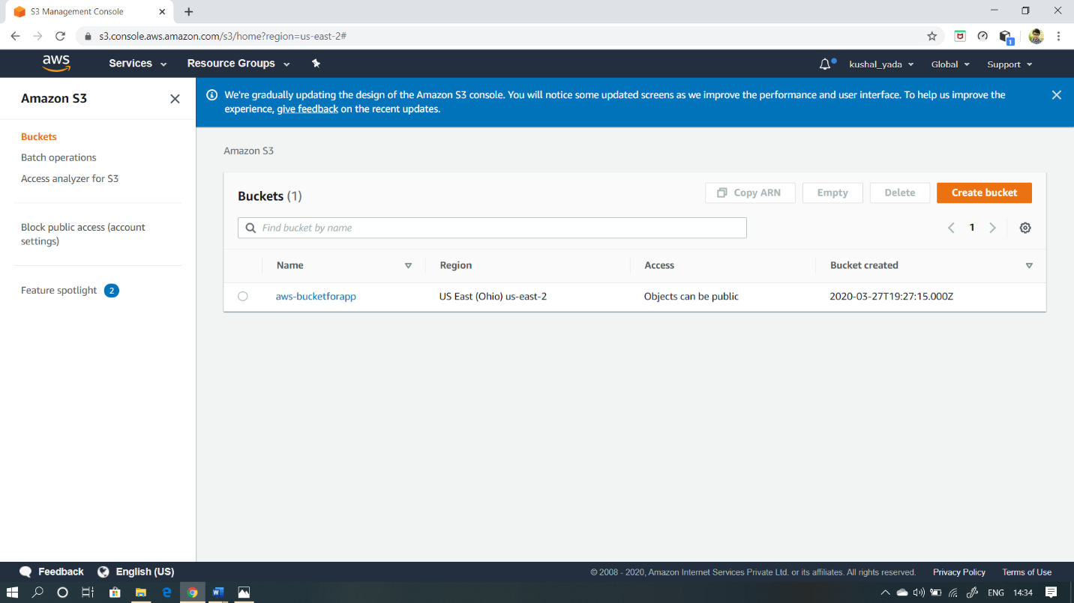

4.REKOGNITION DASHBOARD:

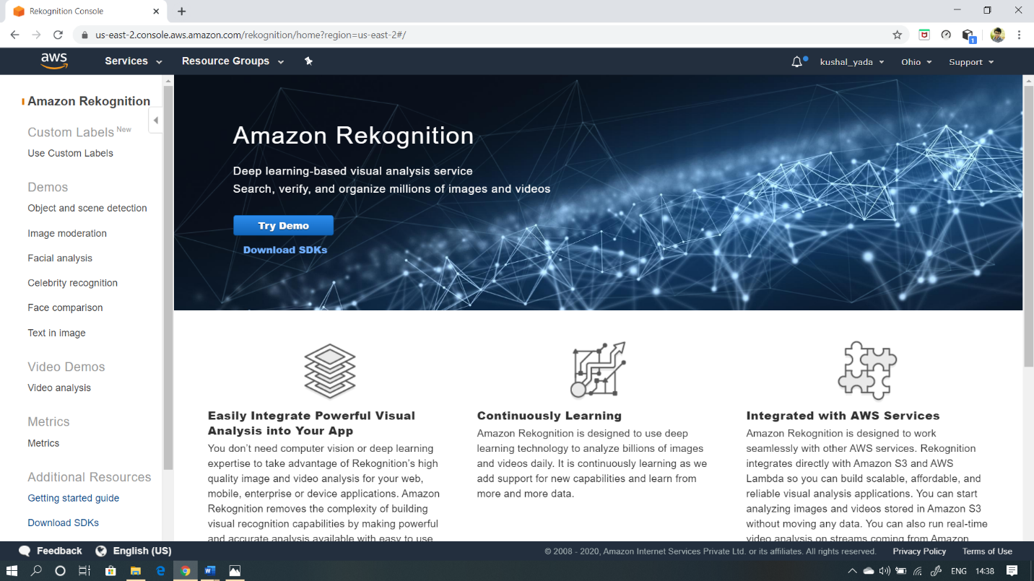

**EC2 SCREENSHOTS:**

1.CHOOSING AN AMI:

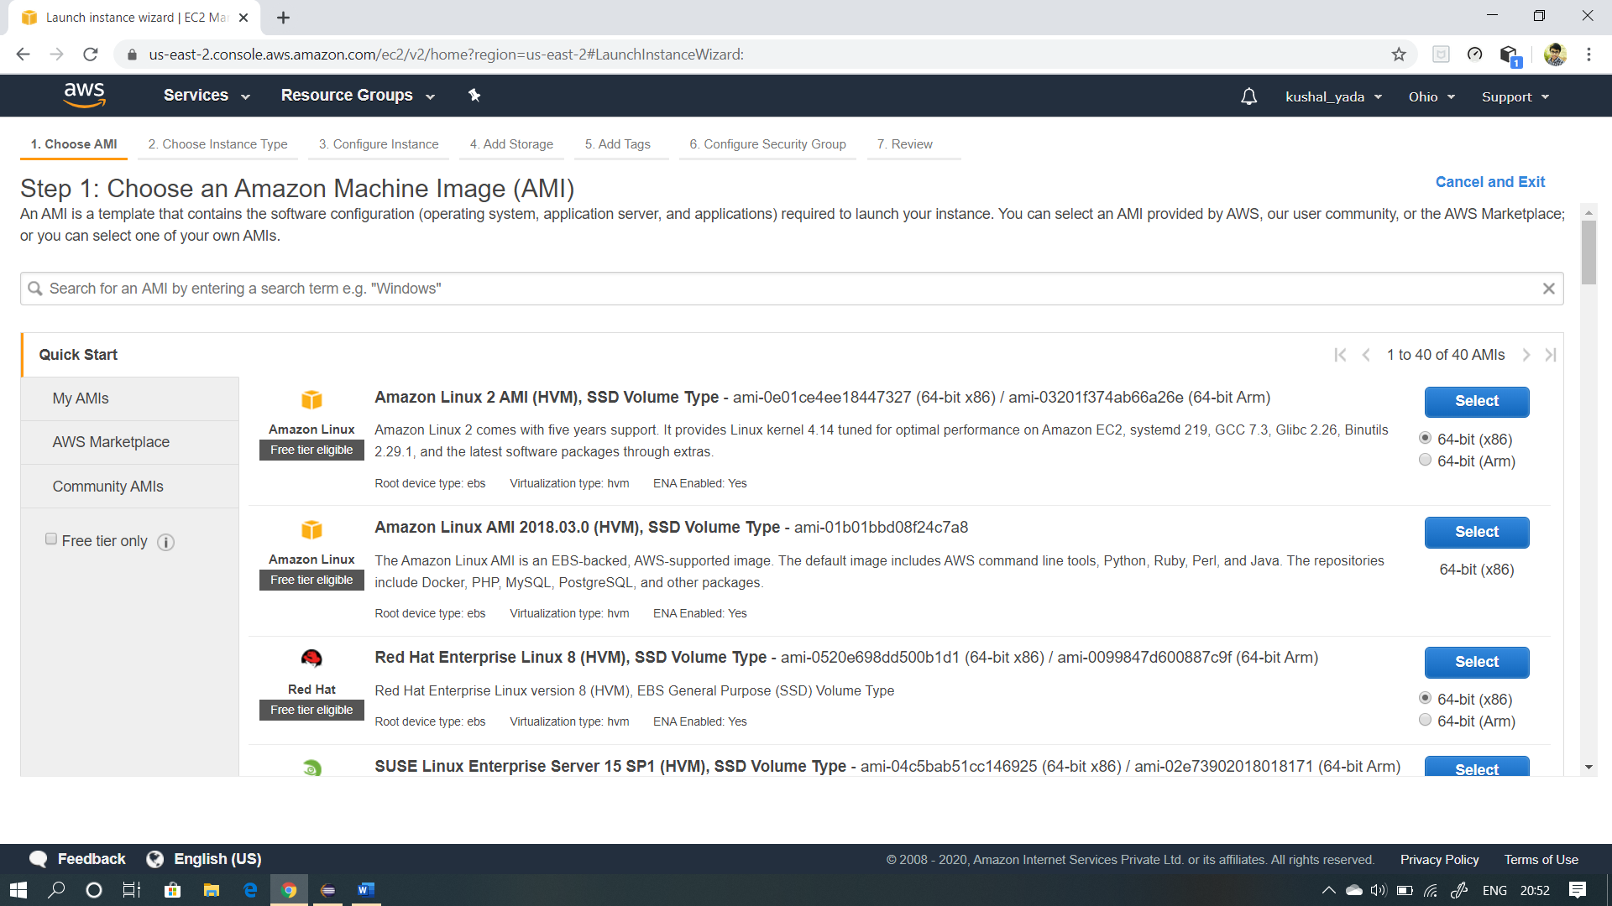

2.CHOOSING AN INSTANCE TYPE:

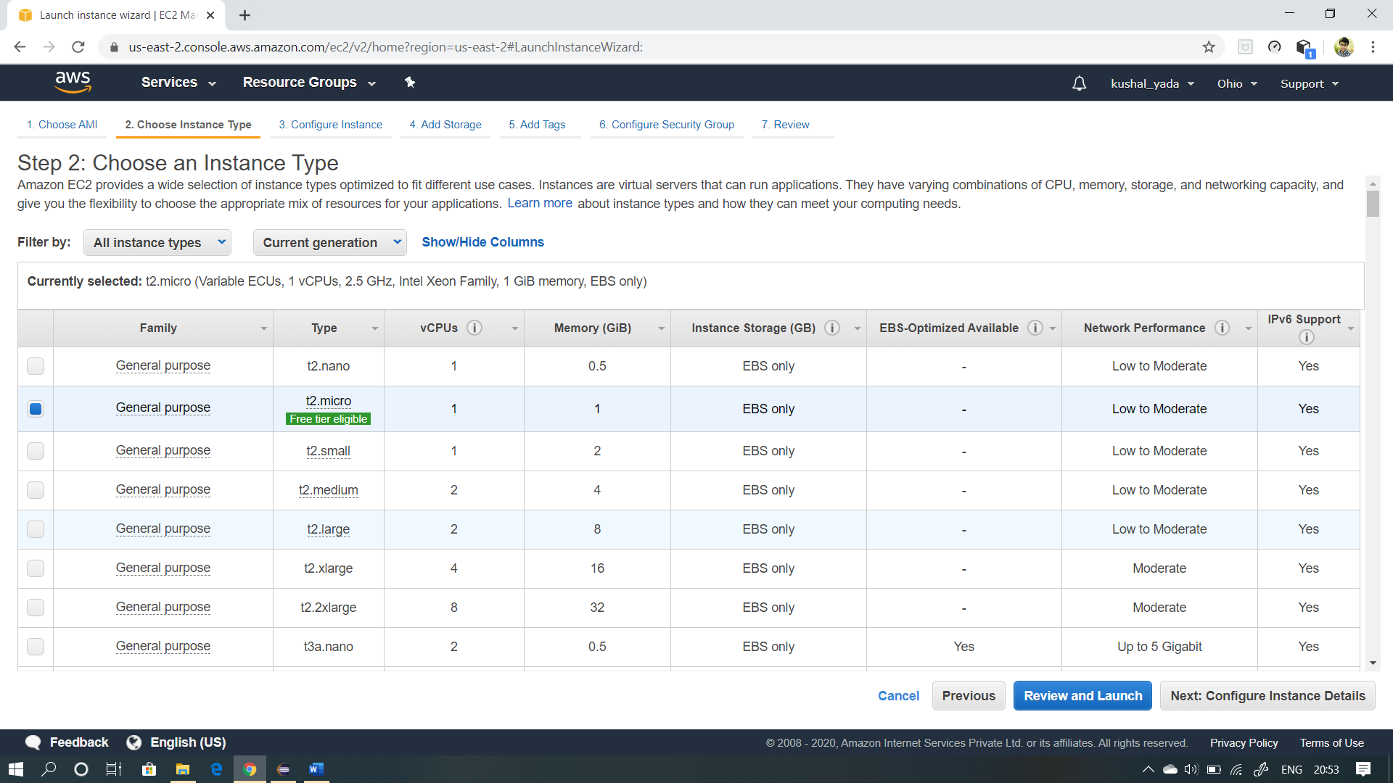

3.ADDING STORAGE:

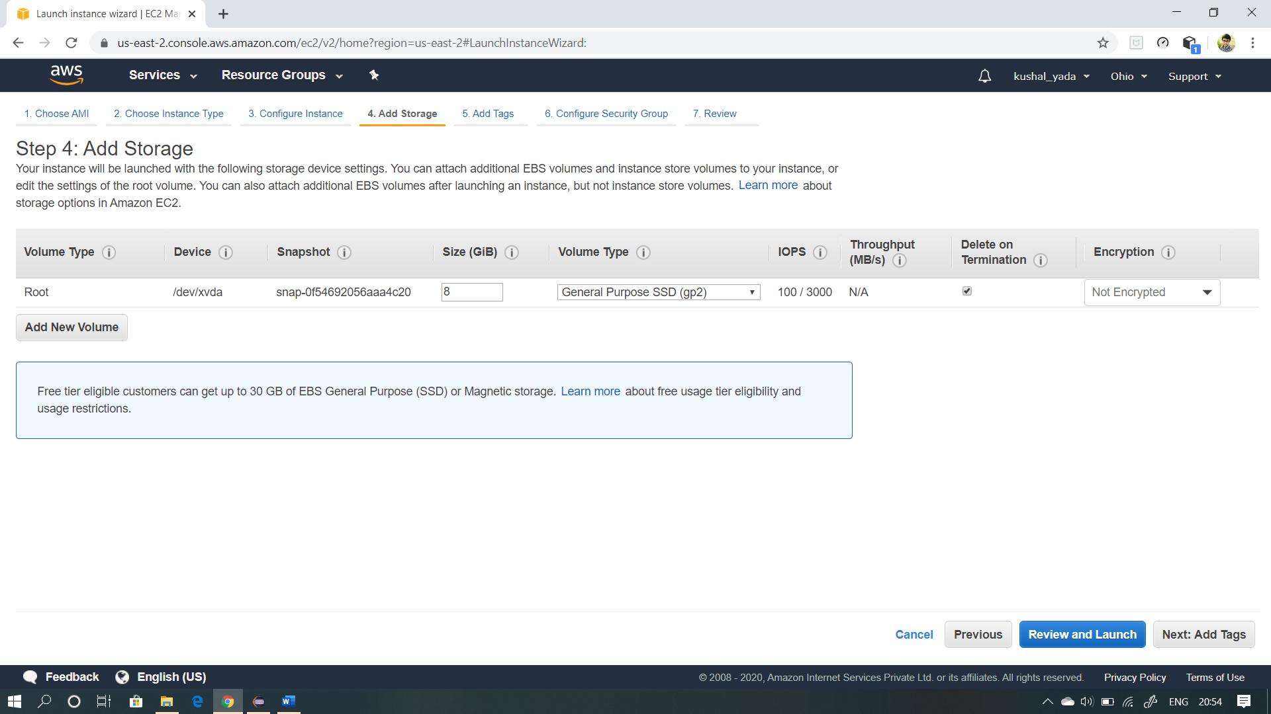

4.CONFIGURING SECURITY GROUP:

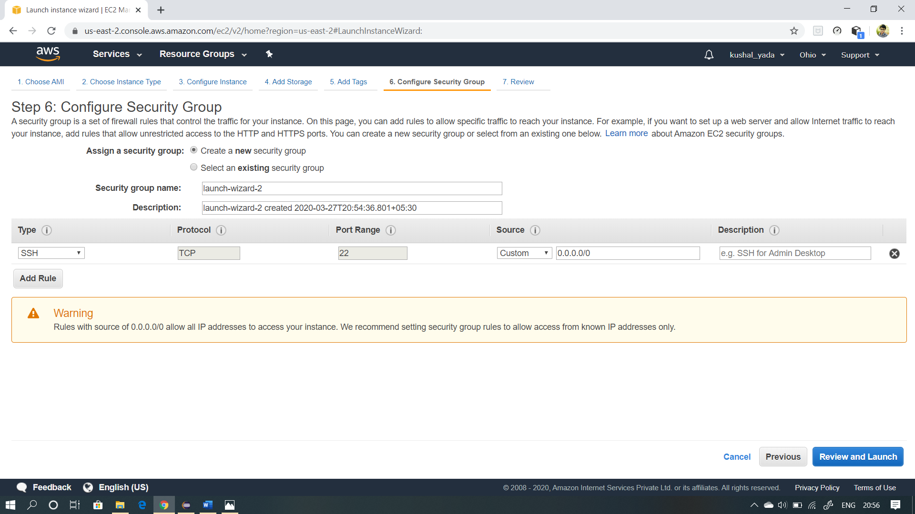

5.KEY PAIR DOWNLOAD:

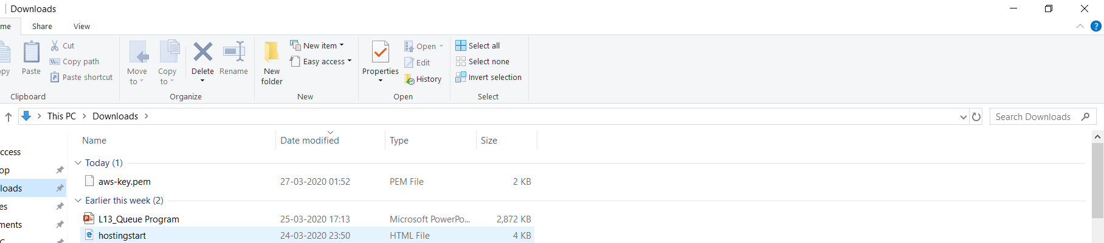

6.PUTTYGEN CONVERSION FROM PEM TO PPK:

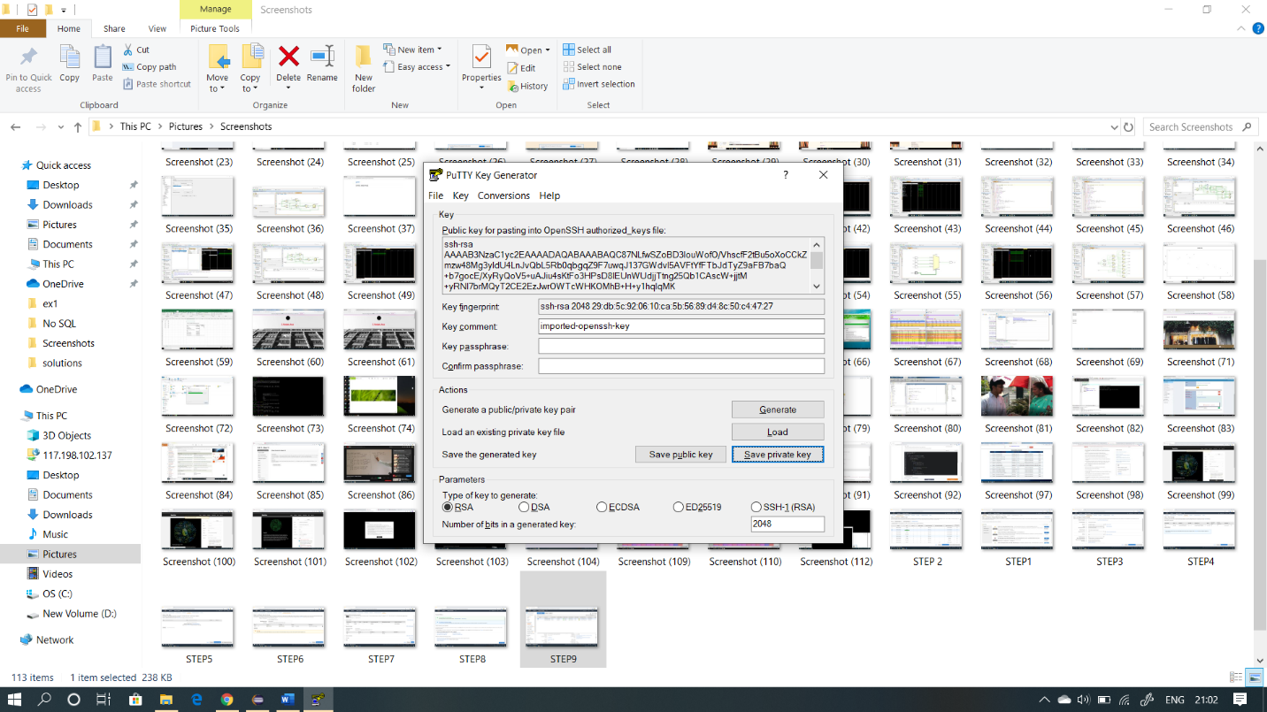

7.LOGGED IN EC2 BLACK SCREEN:

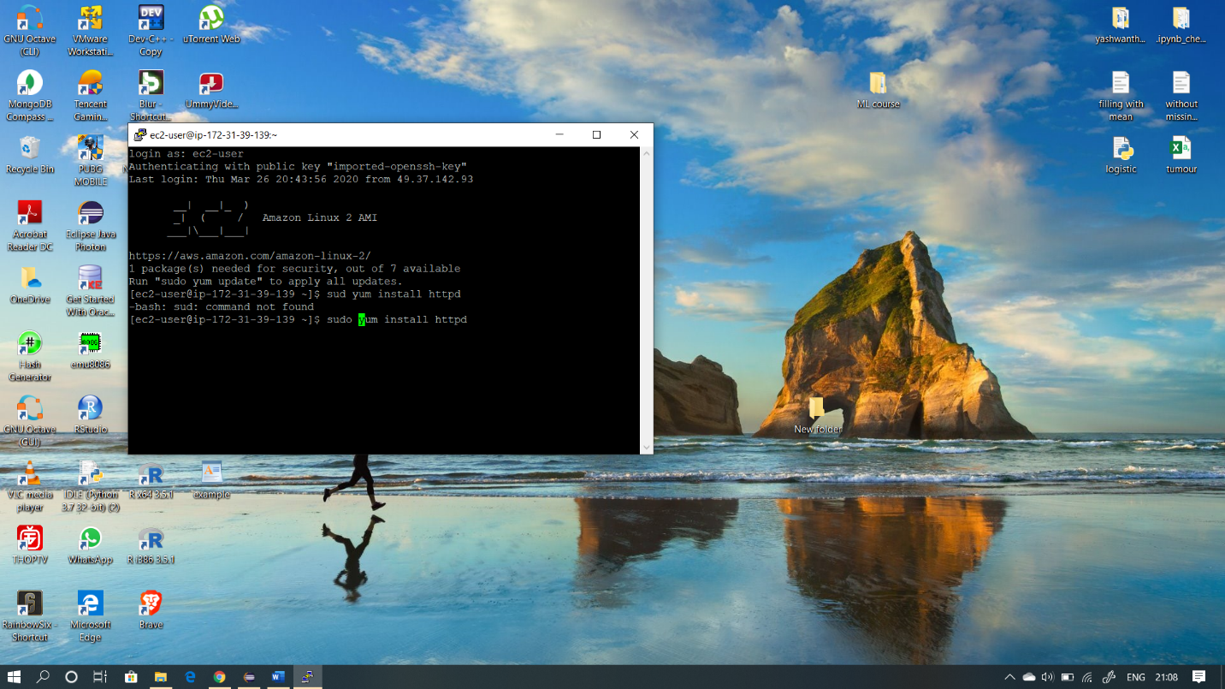

**S3 SCREENSHOTS:**

1.CREATING A BUCKET: 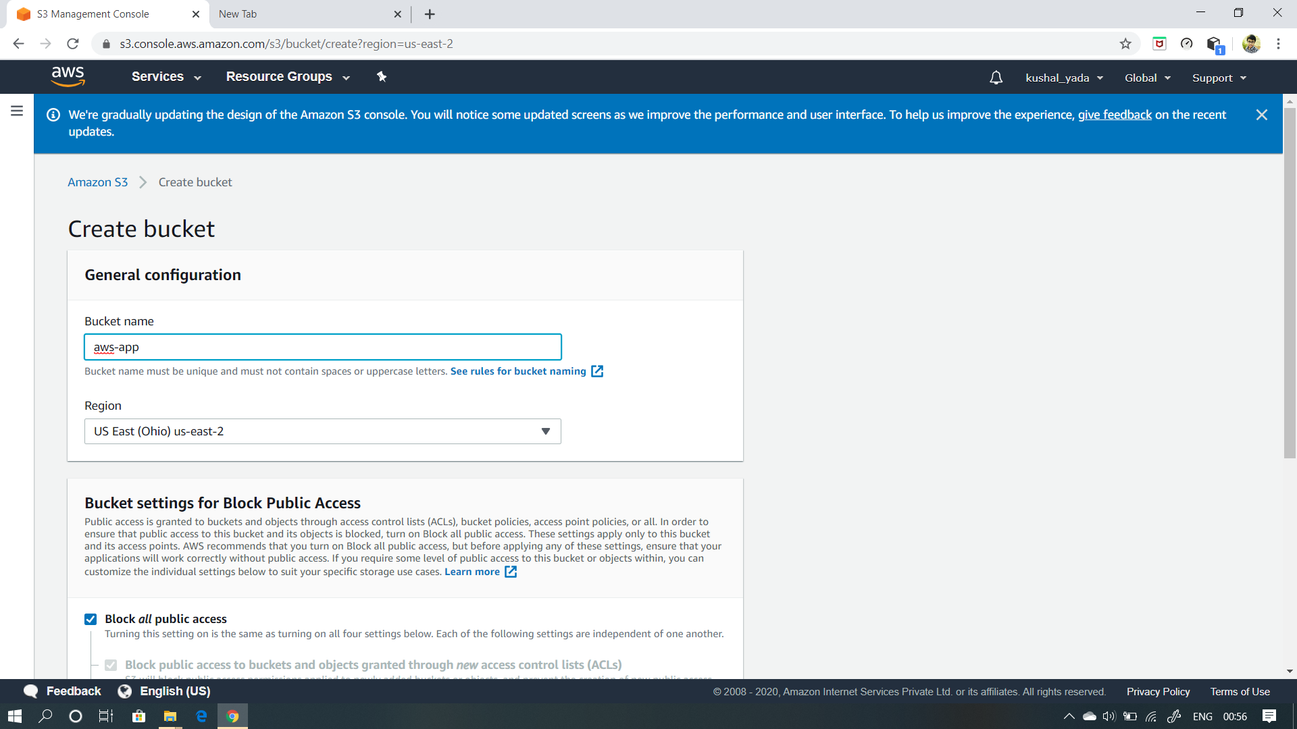

2.UPLOADING AN OBJECT:

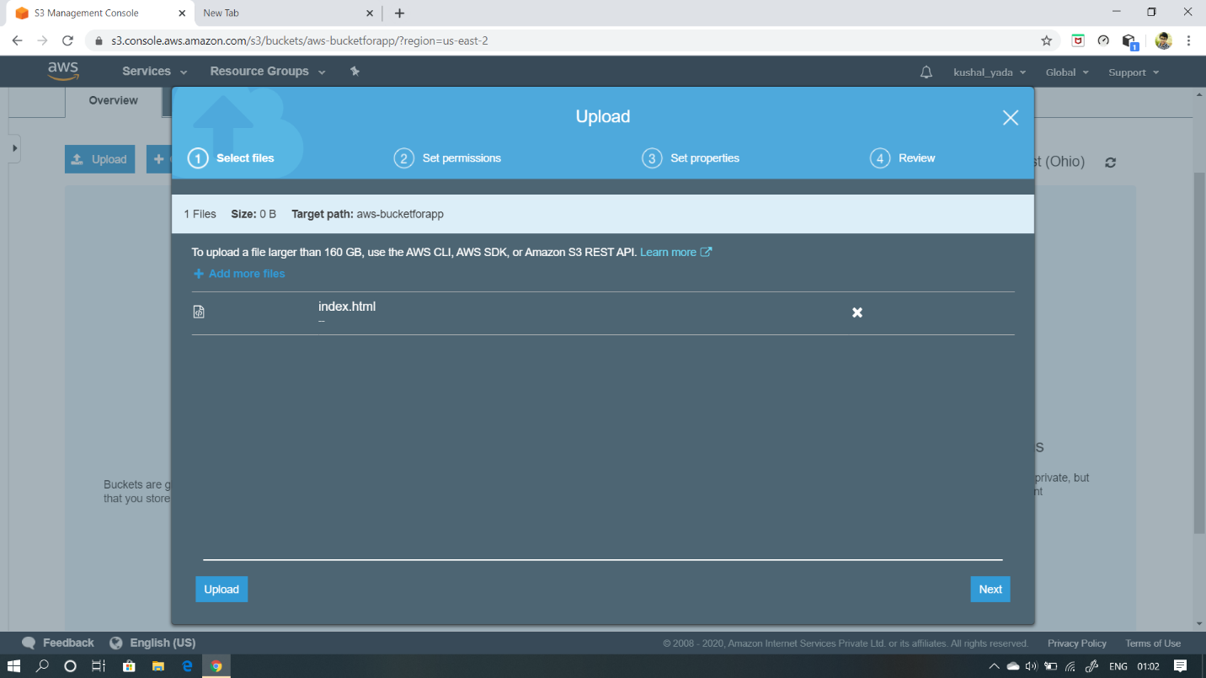

3.ENABLING STATIC WEBSITE:

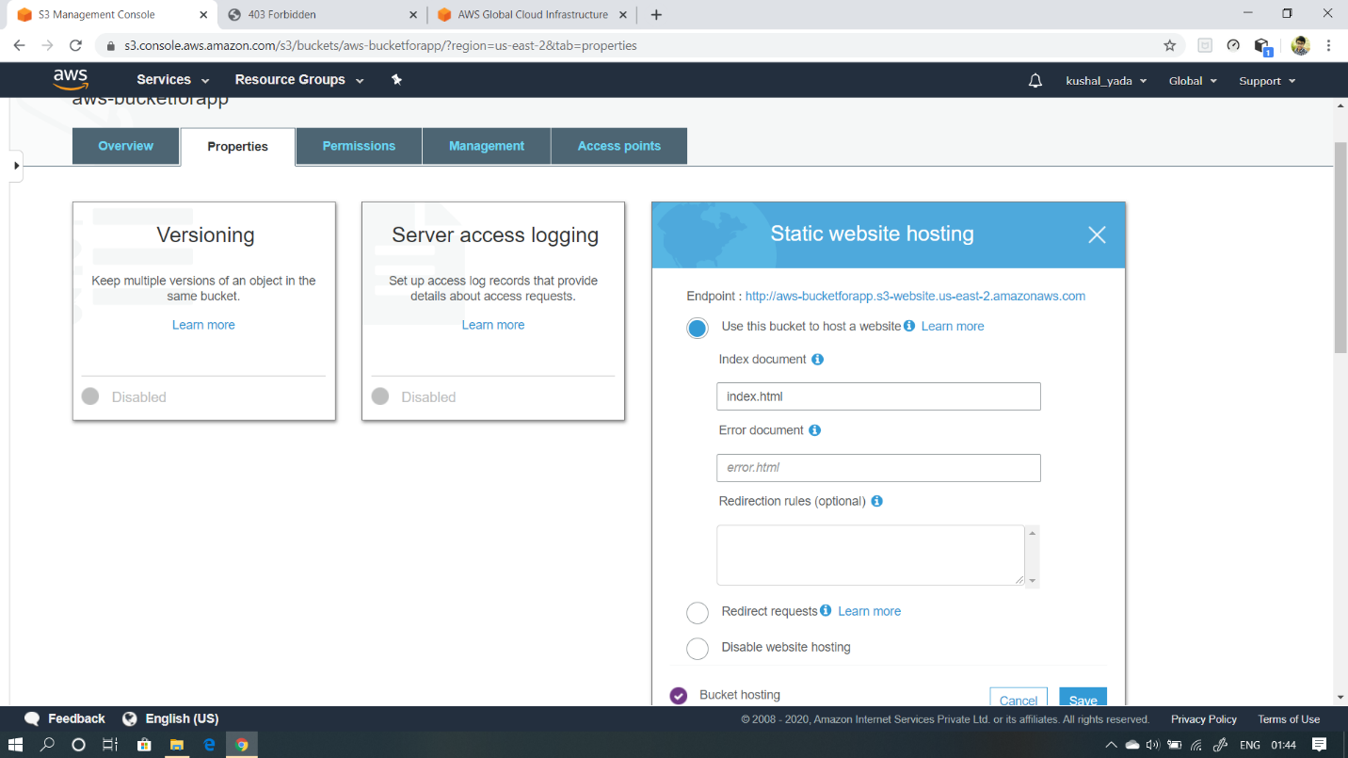

4.MAKING THE OBJECT PUBLIC:

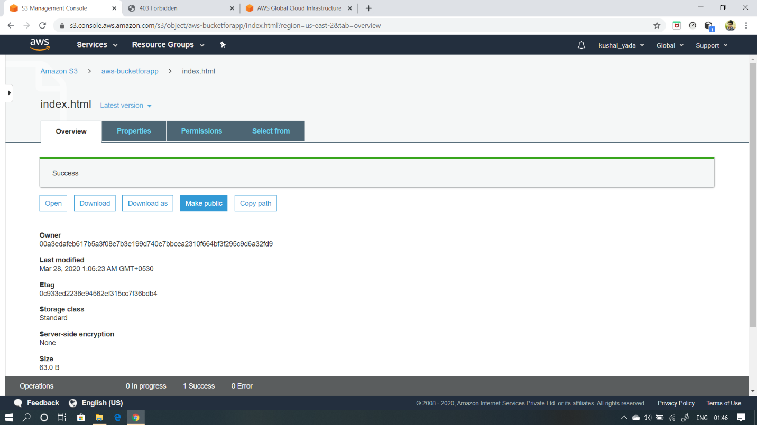

5.CHECKING THE S3 LINK ON THE BROWSER:



**REKOGNITION SCREENSHOTS**

1.FACE DETECT:

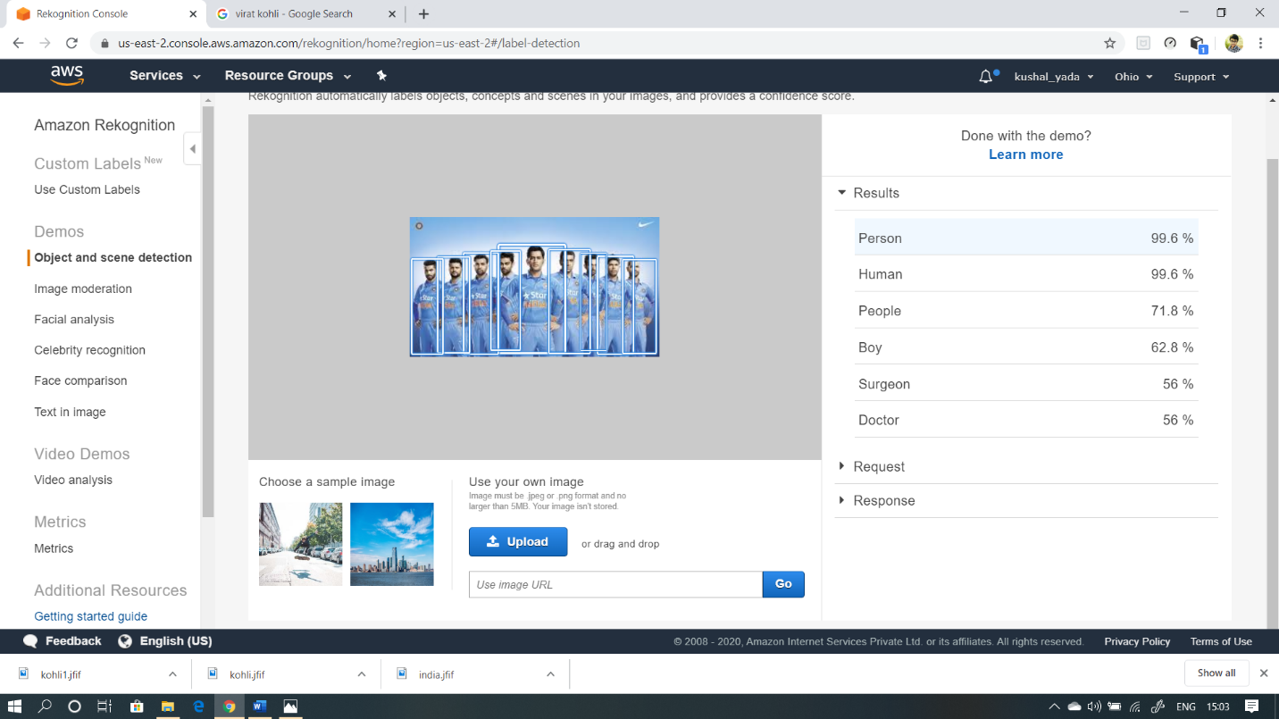

2.FACE COMPARE:

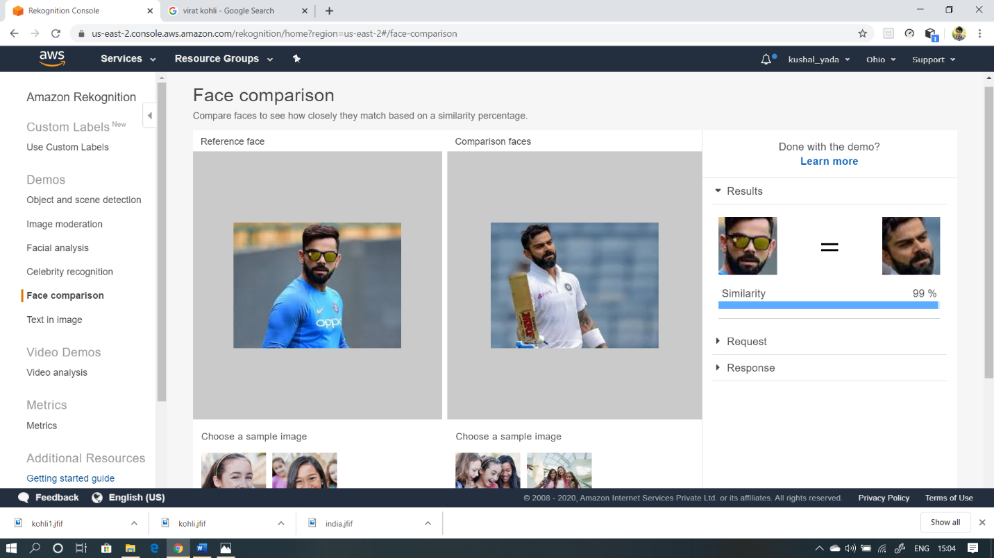

3.CELEBRITY RECOGNITION:

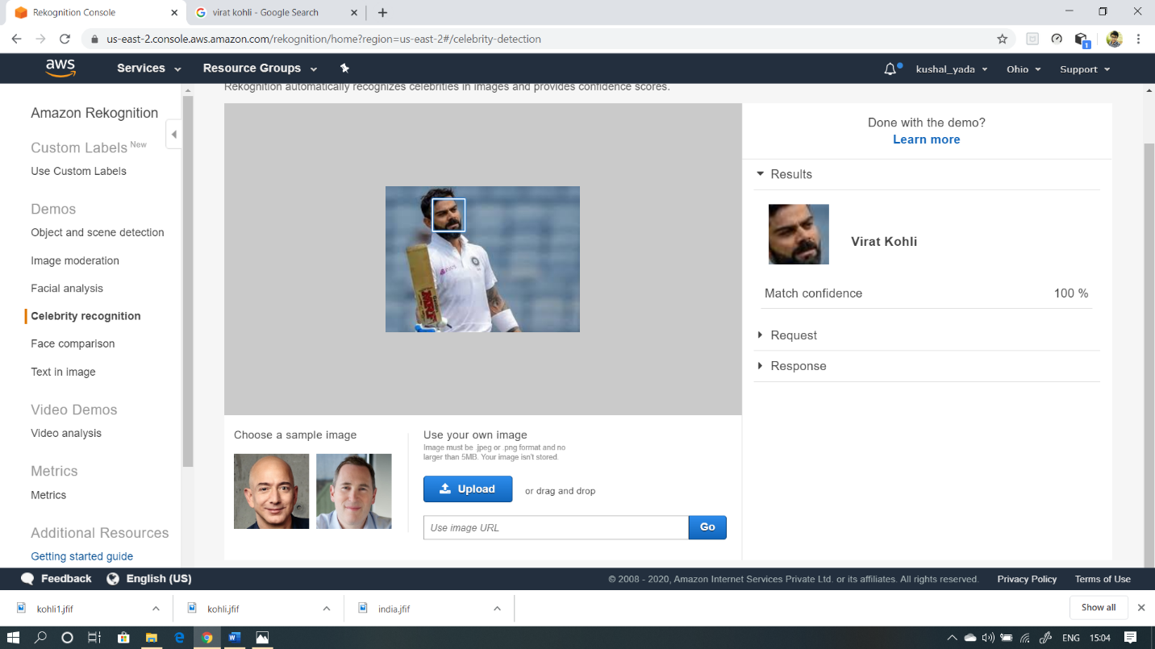

4.TEXT IN IMAGE:

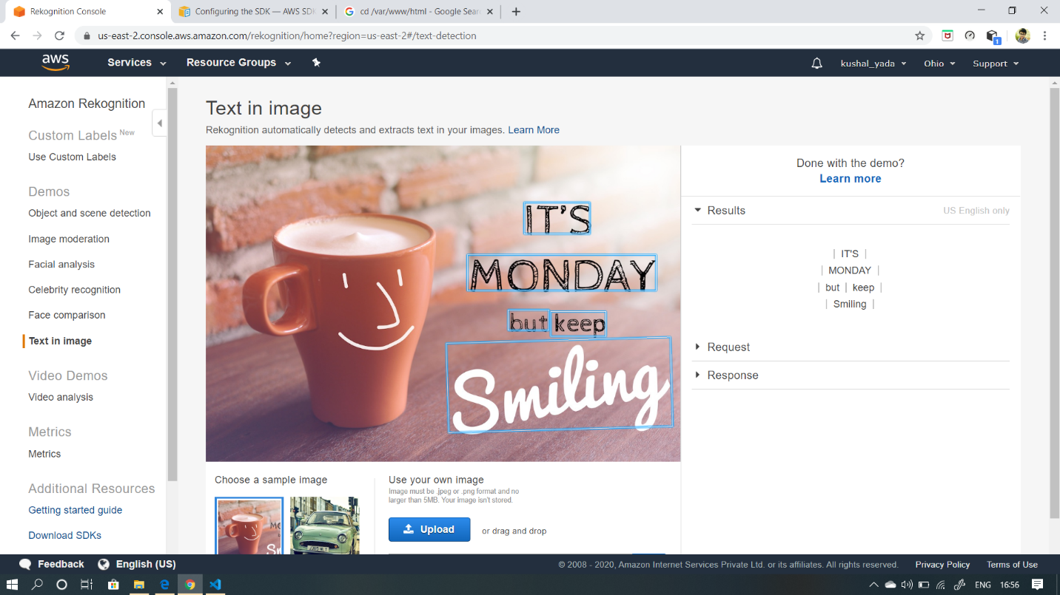

**EC2 AND S3 SCREENSHOTS:**

1.INSTALLING AWS-SDK:

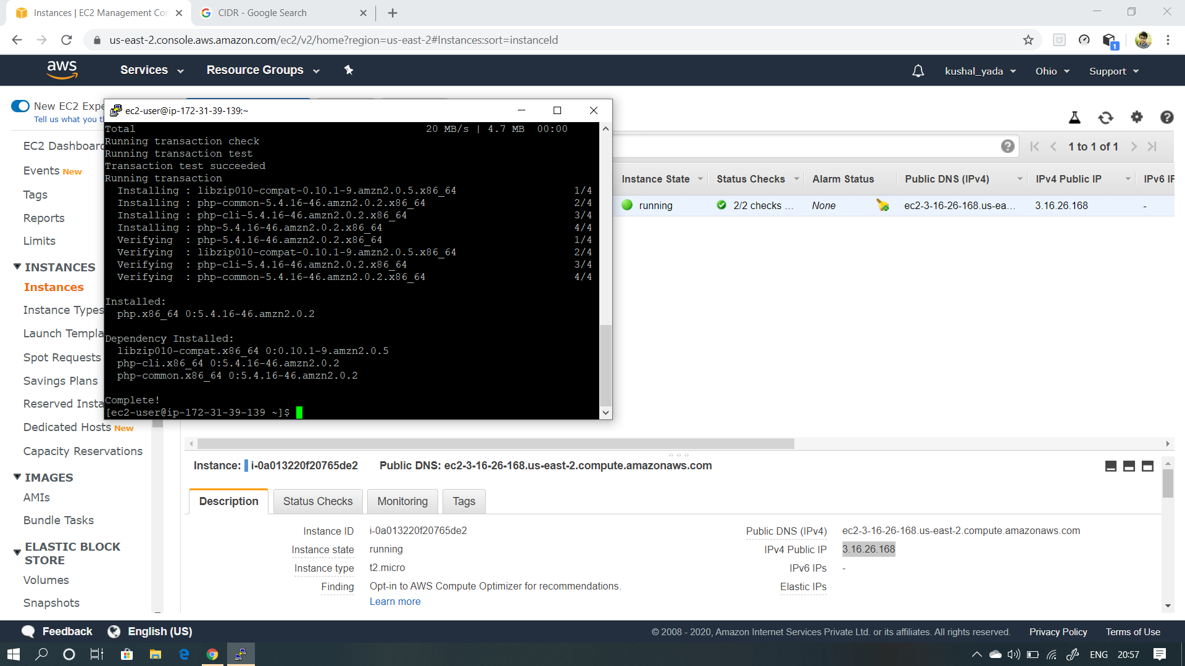

2.INSTALLING PHP:

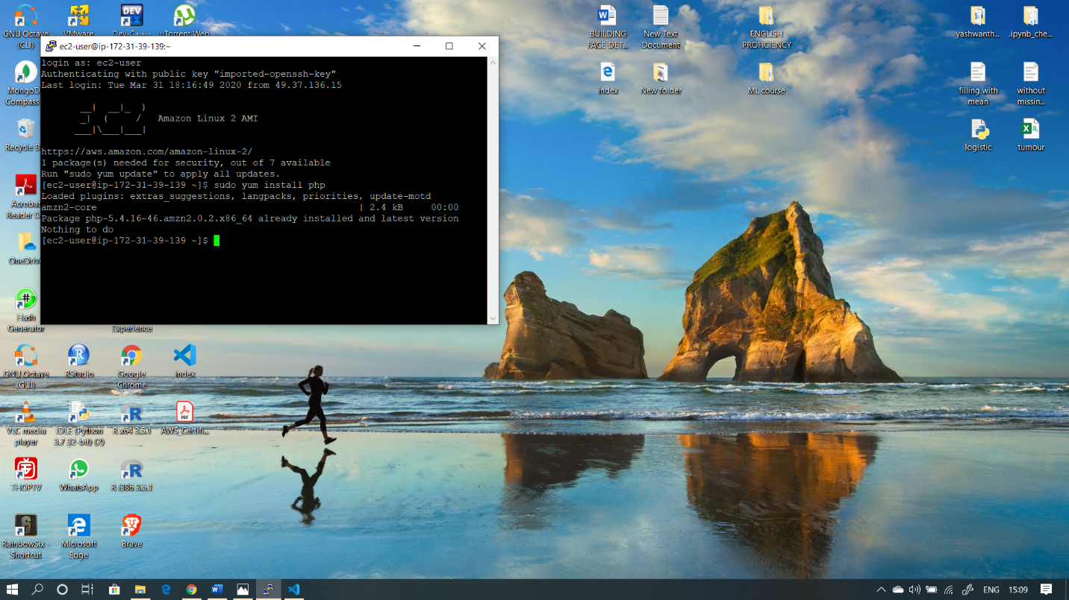

3.INDEX.PHP FILE CODE:

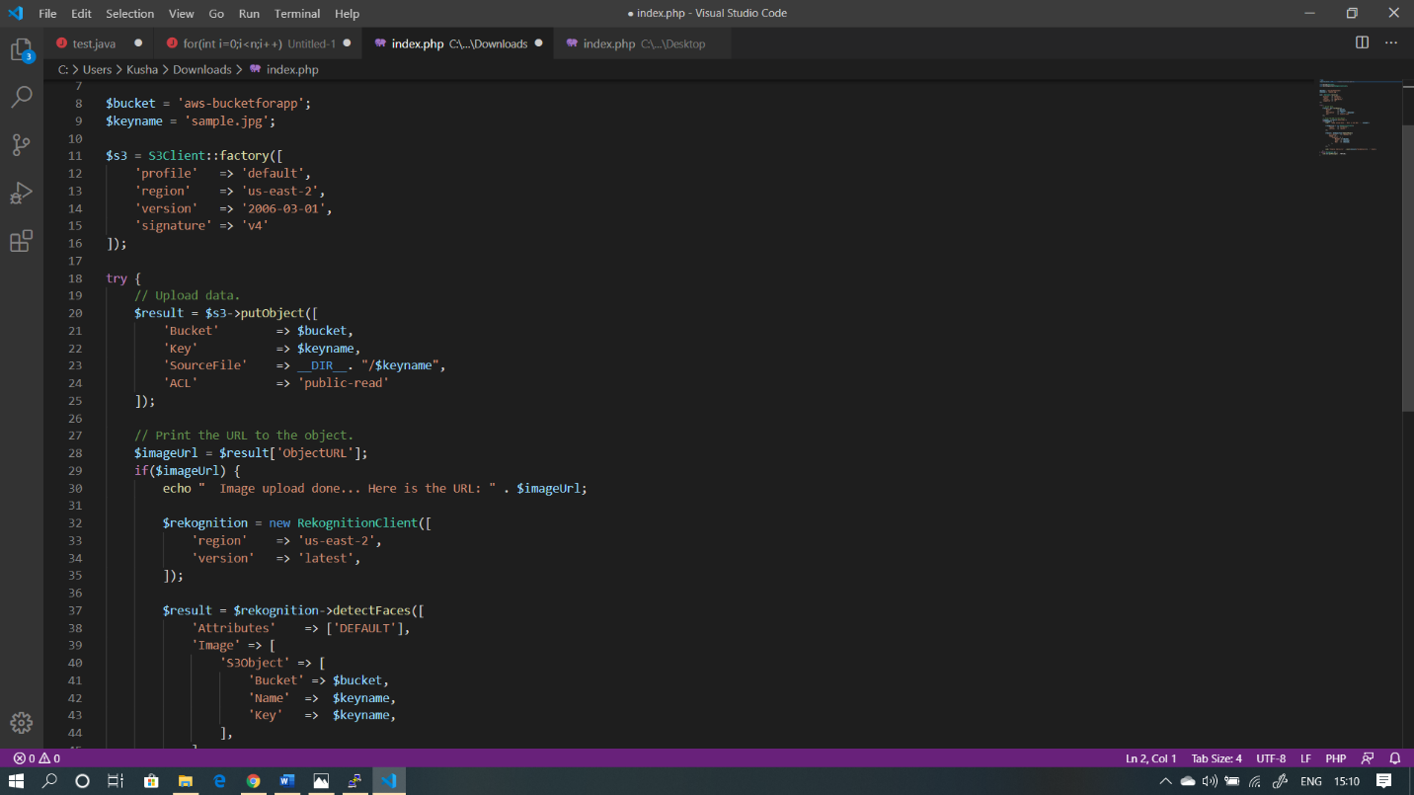

4.UPLOAD SUCCESS SCREENSHOT:

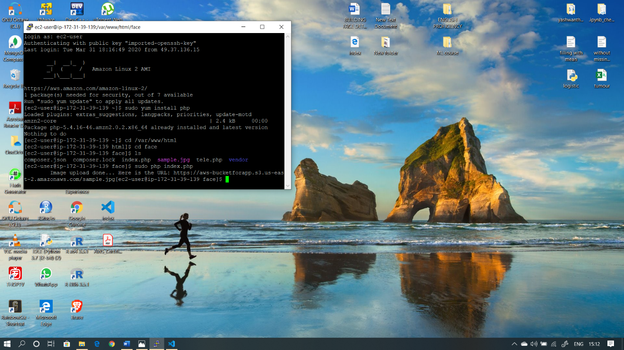

**EC2 AND REKOGNITION SCREENSHOTS:**

1.FACE DETECT SUCCESS :

